 |  |  |  |  |  | - |  |  | -

NAMA ………………………….…………………….. TINGKATAN ………………..……..

MODUL PINTAS 2021
TINGKATAN 5 4531/2

PHYSICS
Kertas 2
Ogos / Sept.

2 ½ jam Dua jam tiga puluh minit

JANGAN BUKA KERTAS SOALAN INI SEHINGGA DIBERITAHU

- Tulis nama dan tingkatan anda pada bahagian yang disediakan.
- Kertas soalan ini adalah dalam dwibahasa.
- Soalan dalam bahasa Melayu mendahului soalan yang sepadan dalam bahasa Inggeris.
- Calon dibenarkan menjawab keseluruhan atau sebahagian soalan sama ada dalam bahasa Inggeris atau bahasa Melayu.
- Calon dikehendaki membaca maklumat di halaman sebelah kertas soalan ini.
Untuk Kegunaan Pemeriksa
Bahagian | Soalan | Markah  Penuh | Markah Diperoleh
A | 1 | 4
A | 2 | 5
A | 3 | 6
A | 4 | 9
A | 5 | 9
A | 6 | 9
A | 7 | 9
A | 8 | 9
B | 9 | 20
B | 10 | 20
C | 11 | 20
Jumlah

Kertas peperiksaan ini mengandungi <<X>> halaman bercetak dan <<X>> halaman tidak bercetak
Maklumat berikut mungkin berfaedah. Simbol-simbol mempunyai makna yang biasa.
The following information may be useful. The symbols have their usual meaning.

1. | a = | 15 | $$λ=\frac{\text{ax}}{D}$$
2. | v² = u² + 2as | 16 | $$\frac{1}{f}=\frac{1}{u}+\frac{1}{v}$$
3 | s = ut + at² | 17 | n₁ sin Ө₁ = n₂ sin Ө₂
4 | W = mg | 18 | Tekanan / Pressure  P =
5 | F = ma | 19 | Daya apungan / Buoyant forve  F = ρ V g
6 | Daya graviti / Gravitational force | 20 | V = IR
7 | Daya memusat / Centripetal force | 21 | Kuasa / Power  P =
8 | Tempoh orbit / Orbital period | 22 | R = R₁ + R ₂  = +
9 | Halaju lepas/ Escape velocity, | 23 | 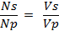
10 |  | 24 | Kecekapan .  Efficiency =
11 | Haba / Heat, Q = mc∆θ | 25 | Tenaga foton / Photon energy  E = h f
12 | Haba / Heat, Q = m l | 26 | Pemalar graviti/ Gravitational constant
13 | v = f λ | 27 | g = 9.81 m s⁻²
14 | T = | 28

Bahagian A
Section A
[60 markah]
[60 marks]
Jawab semua soalan dalam bahagian ini.
Answer all questions in this section.

For Examiner’s Use | 1 | Diberi satu persamaan yang menghubungkan tenaga foton, E dan frekuensi gelombang cahaya, f.  Given an equation relating the photon energy, E and the frequency of light, f.  E = h f
1(a)  1 |  | (a) | Apakah maksud frekuensi?  What is the meaning of frequency?  ................................................................................................................  [1 markah]  [1 mark]
1(b)  1 |  | (b) | Lengkapkan ayat berikut dengan menandakan (√ ) jawapan yang betul..  Complete the following sentence by ticking ( √ ) the correct answer.  Simbol h mewakili  Symbol h represent  pemalar De Broglie  De Brogle constant  pemalar Planck  Plank constant  [1 markah]  [1 mark]
1(c)  1 |  | (c) | Apakah unit S.I. bagi h?  What is the S.I. unit of h?  ................................................................................................................  [1 markah]  [1 mark]

 | (d) | Apakah yang berlaku kepada tenaga foton, E jika frekuensi gelombang cahaya, bertambah.  What will happen to the photon energy, E if frequency of light increases  .............................................................................................................  [1 markah]  [1 mark] | For Examiner’s Use  1(d)  1  Total  A1  4

For Examiner’s Use | 2 | Rajah 2 menunjukkan Bumi, Bulan dan sebuah satelit .Terdapat daya graviti bertindak antara Bumi, Bulan dan satelit.  Diagram 2 shows the Earth, the Moon and a satellite. There is gravitational force acting on the Earth, Moon and satellite.  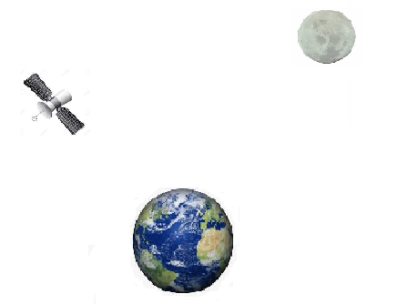  Satelit  Satelite  Bulan  Moon  Bumi  Earth  Rajah 2  Diagram 2
2(a)  1 |  | (a) | Apakah maksud daya graviti?  What is the meaning of gravitational force?  ................................................................................................................  [1 markah]  [1 mark]

 | (b) | Hitungkan daya graviti antara Bumi dengan satelit itu.  [Jisim Bumi = 5.97 × 10²⁴ kg, jisim satelit = 1.2 × 10³ kg, jarak  di antara pusat Bumi dengan pusat satelit = 7.87 × 10⁶ m]  Dimana G adalah pemalar kegravitian, G = 6.67 x 10⁻¹¹ Nm⁻² kg⁻²  Calculate the gravitational force between the Earth and the satellite.  [Earth's mass = 5.97 × 10²⁴ kg, satellite mass = 1.2 × 10³ kg, distance between Earth's center and satellite center  = 7.87 × 10⁶ m]  Where G is gravitational constant, G = 6.67 x 10⁻¹¹ Nm⁻² kg⁻²  [2 markah]  [2 marks] | For Examiner’s Use  2(b)  2
 | (c) | Pasangan jasad yang manakah mengalami daya graviti yang paling kecil? Beri sebab untuk jawapan anda.  Which pair of bodies experience the smallest gravitational force? Give a reason for your answer.  .............................................................................................................  .............................................................................................................  [2 markah]  [2 marks] | 2(c)  2  Total  A2  5

For Examiner’s Use | 3 | Rajah 3 menunjukkan bunyi yang terhasil di udara apabila suatu loceng dipukul oleh suatu pengetuk.  Diagram 3 shows the sound waves produced in air when a gong is hit by a hammer.  Loceng  Gong  Pengetuk  Hammer  Rajah 3  Diagram 3
3(a)  1 |  | (a) | Nyatakan jenis gelombang bunyi?  State the type of sound wave?  ................................................................................................................  [1 markah]  [1 mark]
3(b)(i)  1 |  | (b) | Berdasarkan Rajah 3,  Based on Diagram 3,  - namakan kawasan X.  name region X.  .......................................................................................................  [1 markah]  [1 mark]
3(b)(ii)  1 |  |  | (ii) tentukan panjang gelombang bagi gelombang bunyi yang  dihasilkan oleh loceng.  determine the wavelength of the sound wave produced by the  gong.  .......................................................................................................  [1 markah]  [1 mark]

 | (c) | Kelajuan bunyi di udara ialah 330 m s⁻¹. Hitungkan frekuensi gelombang bunyi itu.  Speed of sound in the air is 330 m s⁻¹. Calculate the frequency of the sound wave.  [2 markah]  [2 marks] | 3(c)  2
 | (d) | Apabila bunyi merambat melalui air, nyatakan apa yang berlaku kepada laju gelombang bunyi..  When sound wave travels through water, state what happens to  the speed of wave.  .............................................................................................................  .............................................................................................................  .............................................................................................................  [1 markah]  [1 mark] | 3(d)  1  Total  A3  7

For Examiner’s Use | 4 | Rajah 4 menunjukkan seekor monyet yang sedang memegang dengan kuat seutas tali ringan yang merentasi sebuah takal tanpa geseran dan dikat dengan setandan pisang yang berjisim 15 kg.  Diagram 4 shows a monkey has a firm hold on a light rope that passes over a frictionless pulley and is attached to a 15 kg bunch of bananas.  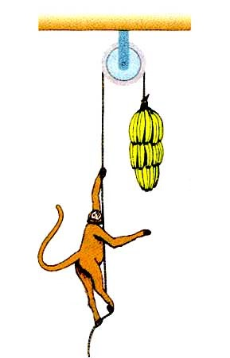  Monyet  Monkey  Pisang  Bananas  Hujung tali X  End of rope X  Rajah 4  Diagram 4  Monyet dan pisang tersebut adalah dalam keseimbangan.  The monkey and the bananas are in equilibrium.
4(a)  1 |  | (a) | Apakah daya paduan yang bertindak keatas sistem takal?  What is the resultant force act on the pulley system?  ................................................................................................................  [1 markah]  [1 mark]
4(b)  2 |  | (b) | Tandakan arah dan labelkan daya-daya yang bertindak ke atas monyet tersebut.  Indicate the direction of forces, label all the forces that act on the monkey.  [2 markah]  [2 marks]

 | (c) | Berapakah berat monyet itu?  What is the weight of the monkey?  ...............................................................................................................  [1 markah]  [1 mark] | 4(c)  1
 | (d) | Seekor monyet yang lain yang berjisim 12 kg ternampak pisang  tersebut dan melompat mendekati pisang dan memegang hujung tali  X. Apakah yang akan terjadi dengan pergerakan kedua-dua monyet tersebut?  Another monkey of mass 12 kg saw the bananas, and jump towards the bananas and hold the end of the rope X. What happened to the motion of both monkeys?  ...............................................................................................................  [1 markah]  [1 mark] | 4(d)(i)  1
 | (e) | Hitungkan  Calculate  (i) pecutan sistem itu  acceleration of the system  (ii) ketegangan tali.  the tension of the rope.  [4 markah]  [4 marks] | 4(d)(ii)  4  Total  A4  9

For Examiner’s Use | 5 | Rajah 5.1 dan Rajah 5.2 menunjukkan corak pinggir yang dihasilkan apabila cahaya monokromatik yang sama melalui dwicelah.  Diagram 5.1 and Diagram 5.2 show fringes formed when identical monochromatic lights pass through the double slits.  y  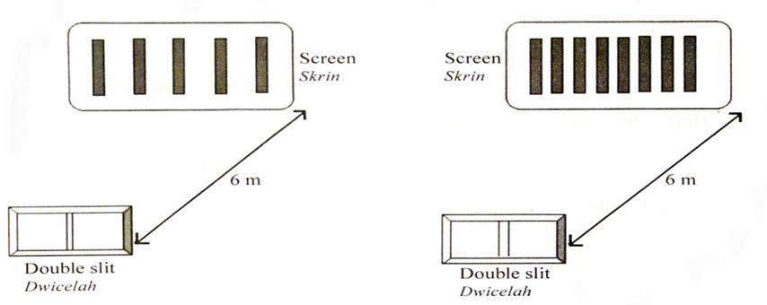  Dwicelah  Double slit  Dwicelah  Double slit  Skrin  Screen  6 m  6 m  a  a  x  x  Rajah 5.1 Rajah 5.2  Diagram 5.1 Diagram 5.2
 |  | (a) | Apakah maksud cahaya monokromatik?  What is the meaning of monochromatic light?  ................................................................................................................  [1 markah]  [1 mark]
5(b)(i)  1 |  | (b) | Berdasarkan Rajah 5.1 dan Rajah 5.2:  Based on Diagram 5.1 and Diagram 5.2:  (i) Bandingkan jarak di antara dua celah, a.  Compare the distance between the slits a, .  ........................................................................................................  [1 markah]  [1 mark]
(ii) Bandingkan panjang gelombang yang melalui dwicelah.
Compare the wavelength of the light that passes through the double slits.

........................................................................................................
[1 markah]
[1 mark]
5(a)
1
5(b)(ii)
1

 | (b) | (iii) Bandingkan jarak di antara dwicelah dengan skrin..  Compare the distance between the double slits and the  Screen.  ........................................................................................................  [1 markah]  [1 mark] |  |  |  | 5(b)(iii)  1
 |  | (iv) Bandingkan jarak di antara pinggir-pinggir, x.  Compare the distance between the fringes, x.  ........................................................................................................  [1 markah]  [1 mark] |  |  |  | 5(b)(iv)  1
 | (c) | Menggunakan jawapan anda di 5(b), nyatakan hubungan antara x dengan a.  Using your answers in 5(b), state the relationship between x and a.  ................................................................................................................  [1 markah]  [1 mark] |  |  |  | 5(c)  1
 | (d) | Berdasarkan Rajah 5.1, jarak pemisahan celah ialah 0.2 mm, panjang gelombang cahaya monokromatik adalah, 450 nm.  Hitungkan jarak y.  Based on Diaram 5.1, the slit separation is 0.2 mm, the wavelength of the monochromatic light is 450 nm. Calculate distance y.  [3 markah]  [3 marks] |  |  |  | 5(d)  3  Total  A5  9
 |  |  | 6 | Rajah 6.1(a) dan 6.2(a) menunjukkan dua susunan litar untuk mengkaji hubungan antara beza keupayaan dan arus bagi satu dawai konstantan yang mempunyai panjang yang berbeza.  Rajah 6.1(b) dan 6.2(b) menunjukkan graf beza keupayaan melawan arus yang sepadan bagi Rajah 6.1(a) dan 6.2(a) masing-masing. Kecerunan graf mewakili rintangan dawai konstantan itu.  Diagram 6.1(a) and 6.2(a) show two circuits used to investigate the relationship between potential difference and electric current of a constantan wire of different length.  Diagram 6.1(b) and 6.2(b) show the graph of potential difference against electric current for Diagram 6.1(a) and 6.2(a) respectively. The gradient of the graph represents the resistance of the constantan wire.  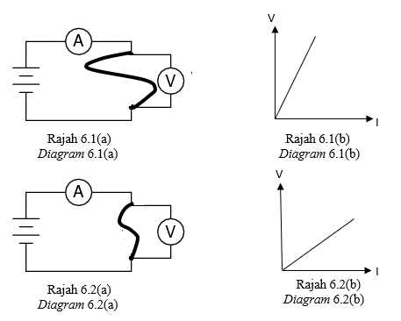
6(a)  1 |  |  |  | (a) | Apakah imaksud beza keupayaan?  What is the meaning of potential difference?  ................................................................................................................  [1 markah]  [1 mark]

 | (b) | Berdasarkan Rajah 6.1 dan 6.2,  Based on Diagram 6.1 and 6.2,  (i) bandingkan panjang dawai konstantan itu.  compare the length of constantan wire.  ......................................................................................................  [1 markah]  [1 mark] | 6(b)(i)  1
 |  | (ii) bandingkan rintangan dawai konstantan itu.  compare the resistance of constantan wire.  ......................................................................................................  [1 markah]  [1 mark] | 6(b)(ii)  1
 |  | (ii) hubungkaitkan panjang dawai dengan rintangan.  relate the length of wire and the resistance.  ......................................................................................................  [1 markah]  [1 mark] | 6(b)(iii)  1
 | (c) | Rajah 6.3 menunjukkan dua perintang X dan Y masing-masing 20 Ω  disambungkan ke sel kering, 6V  Diagram 6.3 shows two resistors X and Y of resistance 20 Ω respectively are connected to dry cell, 6V  I  Y  X  6V  Rajah 6.3  Diagram 6.3
Total
A6
9
For Examiner’s Use  6(c)(i)  2 |  | (c) | Berdasarkan Rajah 6.3,  Based on Diagram 6.3,  Hitungkan  Calculate  (i) Rintangan berkesan litar itu.  Effective resistance of the circuit.  [2 markah]  [2 marks]
6(c)(ii)  1 |  |  | (ii) Arus, I.  Current, I.  [1 markah]  [1 mark]
6(c)(iii)  1 |  |  | (iii) Kuasa yang dilesapkan oleh perintang X.  Power dissipated at resistor X.  [1 markah]  [1 mark]
6(d)  1 |  | (d) | Apakah yang akan berlaku kepada arus I jika perintang X dikeluarkan?  What will happen to the current, I if resistor X is removed?  ................................................................................................................  [1 markah]  [1 mark]
Total
A6
9
7 | Rajah 7.1(a) dan rajah 7.2(b) menunjukkan aksi aktiviti mendarat oleh dua orang atlet  Diagram 7.1(a) and diagram 7.2(b) show two actions on landing activity by two athletes.  Atlet B  Athlete B  Atlet A  Athlete A  Rajah 7.1(a) Rajah 7.2(a)  Diagram 7.1(a) Diagram 7.2(a)
 | (a) | Kedua-dua atlit itu terjun dari ketinggian yang sama dan mendarat di kawasan yang sama.  Both athletes jumped from the same height and fall on the same ground.  Namakan daya yang menyebabkan atlet-atlet itu jatuh.  Name the force that causes the athlete to fall down.  ...............................................................................................................  [1 markah]  [1 mark] |  |  |  | 7(a)  1
 | (b) | Kedua-dua atlet ini berjisim 50 kg melompat dan mendarat dengan halaju 4 ms⁻¹ sebelum mencecah tanah. Masa pendaratan yang diambil oleh kedua-dua atlet A dan atlet B masing-masing adalah  0.5 s dan 0.2 s  Both of these athletes of mass 50 kg jumped and landed with velocity 4 ms⁻¹ before touching the ground. The landed time taken for both athlete A and athlete B are 0.5 s and 0.2 s respectively.  (i) Hitungkan daya impuls yang bertindak ke atas atlet A.  Calculate the impulsive force acted on athlete A.  [1 markah]  [1 mark] |  |  |  | 7(b)(i)  1
For Examiner’s Use  7(b)(ii)  1 |  |  |  |  | (ii) Hitungkan daya Impuls yang bertindak ke atas atlet B.  Calculate the impulsive force acted on athlete B.  [1 markah]  [1 mark]
7(b)(iii)  1 |  |  |  |  | (iii) Apakah kesan masa impak terhadap daya impuls?  What is the effect of time of impact towards the impulsive force?  ......................................................................................................  [1 markah]  [1 mark]
 |  |  |  | (c) | Rajah 7.3 menunjukkan satu set peralatan permainan yang hendak diletakkan pada taman permainan kanak-kanak.  Diagram 7.3 shows a set of playing equipment to be placed in children playground.  Buaian  Swing  Gelongsor  Glider  Tangga  Ladder  Tiang  Pole  Tapak  Ground  Rajah 7.3  Diagram 7.3  Jadual 1 menunjukkan tiga jenis tapak dan ketinggian gelongsor yang digunakan untuk taman permainan tersebut.  Table 1 shows three types of the ground and the height of the glider  used for the playground.

Jadual 1
Jenis  Type | Bahan untuk tapak  Material for the ground | Ketinggian gelongsor  Height of glider
P | Getah  Rubber | 1.0 m
Q | Kayu  Wood | 2.0 m
R | Plastik  Plastic | 3.0 m
Table 1

Cadangkan ciri-ciri yang sesuai untuk taman permainan itu berdasarkan aspek- aspek berikut
Suggest the suitable characteristics for the playground based on
the following aspects.

 |  | (i) Bahan untuk tapak.  Material for the ground.  ........................................................................................................  Sebab  Reason  ........................................................................................................  [2 markah]  [2 marks] |  |  |  | 7(c)(i)  2
 |  | (ii) Ketinggian gelongsor.  Height of glider.  ........................................................................................................  Sebab  Reason  ........................................................................................................  [2 markah]  [2 marks] |  |  |  | 7(c)(ii)  2  7(d)  2
 |  | Berdasarkan jawapan anda dalam 7(c) pilih jenis yang paling  sesuai digunakan untuk taman permainan itu.  Based on your answers in 7(c) choose the most suitable method used  in the playground.  ................................................................................................................  [1 markah]  [1 mark] |  |  |  | Total  A7  9
For Examiner’s Use |  |  | 8 | Rajah 8.1 menunjukkan satu rod kuprum diletakkan di atas dua plat elektrik di antara dua bar magnet.  Diagram 8.1 shows a copper rod is placed on two electrical plates in between two bar magnets.  S  N  Plat elektrik  Electrical plate  Rod kuprum  Copper rod  Magnet  S  Suis  Switch  Reostat  Rheostat  Rajah 8.1  Diagram 8.1
8(a)  3 |  |  |  | (a) | Suis dihidupkan, tanda dan labelkan  The switch is on, mark and label  (i) arah arus, I yang melalui rod kuprum  direction of current, I that flows through the copper rod  (ii) arah medan magnet, M  direction of magnetic field, M  (iii) arah daya, F yang terhasil  direction of the force, F produced  [3 markah]  [3 marks]
8(b)  2 |  |  |  | (b) | Terangkan bagaimana daya itu terhasil.  Explain how the forced is produced.  ................................................................................................................  ................................................................................................................  ................................................................................................................  [2 markah]  [2 marks]
 | (c) | Rajah 8.2 menunjukkan sebuah motor electrik yang ringkas.  Diagram 8.2 shows a simple electrical motor.  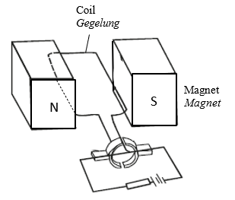  Rajah 8.2  Diagram 8.2  Cadangkan pengubahsuaian yang boleh dilakukan supaya motor elektrik itu boleh berfungsi dengan lebih berkesan.berdasarkan aspek-aspek berikut:  Suggest modification that can be done so that the electrical motor enable to function effectively based on these aspects:
 |  | (i) Ketebalan dawai gegelung  Thickness of coil  ........................................................................................................  Sebab  Reason  ........................................................................................................  [2 markah]  [2 marks] |  |  |  | 7(c)(i)  2

Total
A8
9
For Examiner’s Use  8(c)(ii)  2 |  | (c) | (ii) Bentuk magnet  Shape of magnet  ........................................................................................................  Sebab  Reason  ........................................................................................................  [2 markah]  [2 marks]

Bahagian B
Section B
[20 markah]
[20 marks]
Jawab mana-mana satu soalan daripada bahagian ini.
Answer any one question from this section.

9 | Rajah 9.1 menunjukkan satu batang penyedut minuman keluli tanpa karat di dalam segelas minuman ais. Penyedut minuman itu mencapai keseimbangan terma.  Diagram 9.1 shows a stainless-steel straw in a glass of ice drink. The stainless-steel straw achieved thermal equilibrium.  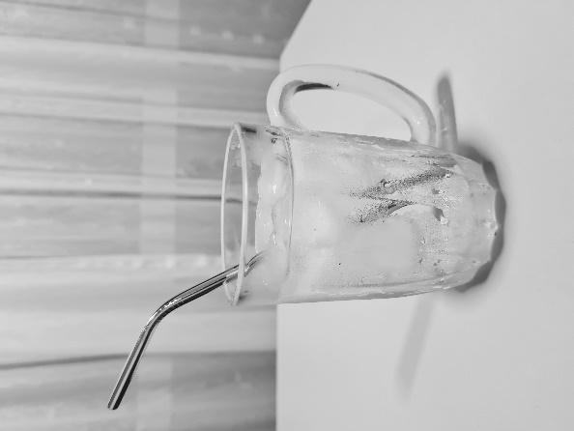  Minuman ais  Ice drink  Penyedut minuman keluli tanpa karat  Stainless-steel straw  Rajah 9.1  Diagram 9.1
 | (a) | Apakah maksud keseimbangan terma?  What is the meaning of thermal equilibrium?  [1 markah]  [1 mark]
 | (b) | Berpandukan kepada konsep keseimbangan terma, terangkan bagaimana penyedut minuman keluli tanpa karat itu menjadi sejuk seperti minuman ais di dalam gelas?  Based on the concept of thermal equilibrium, explain how the stainless-steel straw becomes as cold as the ice drink in the glass?  [4 markah]  [4 marks]
 | (c) | Rajah 9.2 menunjukkan beg makanan yang diguna oleh seorang murid untuk membawa makanan ke sekolah. Dia mendapati bahawa makanan sudah menjadi sejuk semasa waktu rehat.  Diagram 9.2 shows a food bag used by a student to bring his food to the school. He noticed that the food become cold during recess time.  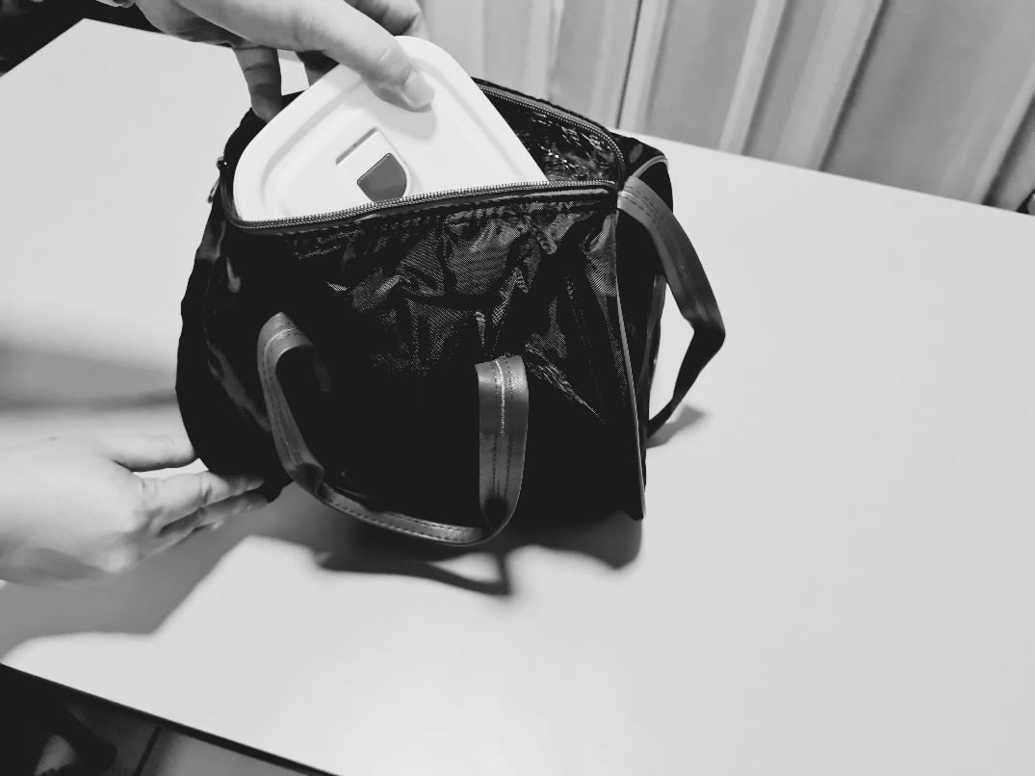  Beg makanan  Food bag  Lapisan dalaman beg makanan  Inner layer of food bag  Rajah 9.2  Diagram 9.2  Jadual 2 menunjukkan spesifikasi empat jenis beg makanan tengah hari P, Q, R dan S, yang boleh digunakan oleh murid tersebut untuk membawa makanan ke sekolah.  Table 2 shows the specification of four types of lunch bag P, Q, R and S, that can be used by the student to bring his food to school.  Jadual 2  Table 2  Anda dikehendaki menentukan kessesuaian beg makanan untuk mengekalkan haba selama beberapa jam. Terangkan kesesuaian setiap spesifikasi. Pilih beg makanan yang paling sesuai dan beri sebab untuk pilihan anda.  You are required to determine the most suitable food bag that can be used to keep the food warm for a few hours. Explain the suitability of each specification. Choose the most suitable food bag and give reasons for your choice.  [10 markah]  [10 marks]
  Jenis beg  Type of bag | Bahan beg makanan  Material of food bag | Lapisan dalam beg makanan  Inner layer of food bag | Muatan haba tentu  Beg makanan  Specific heat capacity of food bag (J kg⁻¹ ˚C⁻¹) | Ketumpatan beg makananan  Density of food bag
  P | Plastik  Plastic | Permukaan berkilat  Shiny surface | 1670 | Rendah  Low
  Q | Kain  Cloth | Permukaan pudar  Dull surface | 1340 | Rendah  Low
  R | Kain  Cloth | Permukaan berkilat  Shiny surface | 925 | Tinggi  High
  S | Plastik  Plastic | Permukaan pudar  Dull surface | 2500 | Tinggi  High
 | (d) | Rajah 9.3 menunjukkan sebuah thermometer yang belum ditentuukurkan yang mempunyai panjang turus merkuri 4.0 cm pada suhu 0˚C dan 22.0 cm pada 100˚C. Panjang turus merkuri menjadi 17.5 cm apabila direndam dalam cecair P.  Diagram 9.3 shows a non-calibrated thermometer. The thermometer has a mercury column of length 4.0 cm at the temperature of 0˚C and 22.0 cm at 100˚C. The mercury column becomes 17.5 cm when it is immersed into the  liquid P.    Rajah 9.3  Diagram 9.3  (i) Nyatakan satu sebab kenapa merkuri digunakan sebagai cecair dalam thermometer?  Give one reason why mercury is used as the liquid in thermometer?  [1 markah]  [1 mark]
(ii) Tentukan suhu cecair P itu dalam Kelvin.
Determine the temperature of liquid P in Kelvin.

[4 markah]
[4 marks]

10  Neraca spring  Spring balance | Rajah 10.1 menunjukkan radas yang digunakan oleh seorang murid dalam mengkaji Prinsip Archimedes.  Diagram 10.1 shows the apparatus used by a student to study Archimedes’ Principle.  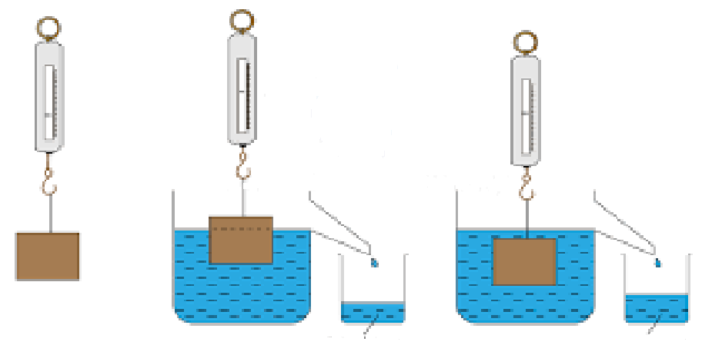  20 N  14 N  10 N  (a) (b) (c)  Air tersesar  Displaced water  Air tersesar  Displaced water  Rajah 10.1  Diagram 10.1  Tin Eureka  Eureka can  Blok logam  Metal block  Bikar  Beaker  Rajah 10.1 (a) menunjukkan blok logam di ukur oleh sebuah neraca spring. Bacaannya adalah 20 N.  Rajah 10.1 (b) menunjukkan blok logam separa terendam dalam air. Bacaan neraca spring adalah 14 N.  Rajah 10.1 (c) menunjukkan blok logam diturunkan sehingga terendam penuh dalam air. Bacaan neraca spring adalah 10 N.  Diagram 10.1 (a) shows a metal block is measured by a spring balance, The reading is 20 N.  Diagram 10.1 (b) shows the metal block is semi -submerged in the water.  The reading of spring balance is 14 N.  The density of water is 1 x 10³ kg m⁻³.  Diagram 10.1 (c) shows the metal block being lowered until fully submerged in water. The reading of the spring balance is 10 N.
 | (a) | Apakah maksud Prinsip Archimedes?  What is the Archimedes’ Principle?  [1 markah]  [1 mark]
 | (b) | Berdasarkan Rajah 10(a), (b) dan (c):  Based on Diagrams 10(a), (b) and (c):  (i) Apakah daya apungan yang bertindak ke atas blok logam pada Rajah 10(b)?  What is the buoyant force acting on the metal block in Diagram 10(b)?  [1 markah]  [1 mark]  (ii) Hitungkan isipadu blok logam pada Rajah 10.  Ketumpatan air adalah 1 x 10³ kg m⁻³.  Calculate the volume of the metal block in Diagram 10.  The density of water is 1 x 10³ kg m⁻³  [3 markah]  [3 marks]  (iii) Rajah 10(b) dan (c) menunjukkan isipadu air tersesar bertambah apabila bongkah logam diturunkan ke dalam air. Apakah akan berlaku kepada isipadu air tersesar jika bongkah itu diturunkan lagi ke dalam air?  Diagrams 10(b) and (c) show that the volume of displaced water increases when the metal block is lowered into the water. What would happen to the displaced water if the block is lowered further into the water?  [1 markah]  [1 mark]
 | (c) | Kenderaan penyelam laut dalam (DSV) diperlukan oleh satu syarikat perlombongan laut untuk menjalankan operasi penyelamat laut dalam. Kenderaan mesti dapat tenggelam dan timbul dengan cepat, bergerak dengan kelajuan mengufuk tinggi dan membawa sejumlah anak kapal dengan selamat.  A deep submergence vehicle (DSV) is required by a marine mining company to carry out deep sea rescue operations. The vehicle must be able to submerge and emerge quickly, travel at high horizontal speeds and carry a number of crew safely.  Ciri-ciri empat DSV P, Q, R dan S diberikan dalam Jadual 3 di bawah.  The characteristics of four DSVs P, Q, R and S are given in the Table 3 below.  Jadual 3  Table 3  Terangkan kesesuaian setiap ciri yang disenaraikan dan tentukan DSV mana yang harus dipilih. Beri sebab untuk pilihan anda.  Explain the suitability of each characteristic listed and determine which DSV should be chosen. Give reasons for your choice.  [10 markah]  [10 marks]
  DSV | Bentuk  Shape | Isipadu tangki ballast  Volume of ballast tanks | Bilangan tangki udara termampat  Number of pressurised air tanks | Tekanan maximum yang dapat ditahan Maximum pressure withstood
  P | Lonjong  Streamlined | 9000 litre | 20 | 6.1 atm
  Q | Bulat  Rounded | 4500 litre | 20 | 7.5 atm
  R | Lonjong  Streamlined | 6000 litre | 18 | 6.0 atm
  S | Lonjong  Streamlined | 9000 litre | 18 | 3.1 atm
 | (d) | Rajah 10.2 menunjukkan seorang budak menolak sebuah bola ke bawah permukaan air. Apabila dilepaskan, bola itu meluru ke atas, keluar dari air.  Diagram 10.2 shows a person pushing a ball below the surface of the water. When released, the ball rushes upwards, out of the water.  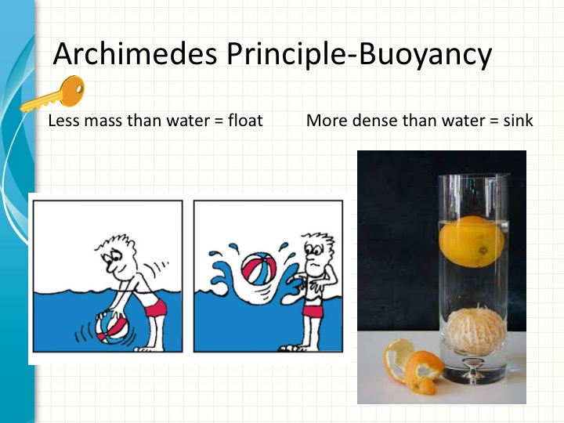  Rajah 10.2  Diagram 10.2
(ii) Terangkan bagaimana situasi ini terjadi.
Explain how this situation happens..
[4 markah]
[4 marks]

Bahagian C
Section C
[20 markah]
[20 marks]
Jawab semua soalan dalam bahagian ini.
Answer all questions in this section.

11 | Rajah 11.1 dan 11.2 menunjukkan biasan cahaya melalui dua medium yang berbeza ketumpatan. Indeks biasan medium X dan Y adalah masing-masing 1.51 dan 2.05. Diagram 11.1 and 11.2 show refraction of light through two mediums of different density. Refractive index of medium X and Y are 1.51 and 2.05 respectively.  Rajah 11.1  Diagram 11.1  sinar tuju  incident ray  garis normal  normal line  60 ⁰  35 ⁰  60 ⁰  Medium X  Medium Y  sinar biasan  refracted ray  25 ⁰  Rajah 11.2  Diagram 11.2
 | (a) | Apakah maksud indeks biasan?  What is the meaning of refractive index?  [1 markah]  [1 mark]
 | (b) | Berdasarkan Rajah 11.1 dan 11.2,  Based on Diagram 11.1 and 11.2  (i) Bandingkan sudut biasan, Indeks biasan dan ketumpatan antara medium X  dengan medium Y.  Compare the refracted angle, refractive index and the density between  medium X and medium Y.  (ii) Hubungkaitkan antara sudut biasan dengan indeks biasan untuk membuat kesimpulan tentang hubungan antara indeks biasan dengan ketumpatan medium.  Relate the refracted angle with the refractive index to make a deduction on the relationship between refractive index and the density of the medium.  [5 markah]  [5 marks]
 | (c) | Rajah 11.3 menunjukkan struktur satu fiber optik.  Diagram 11.3 shows the structure of an optical fiber..  Lapisan luar  Outer cladding  Teras dalam  Inner core  Fiber optik  Optical fibre  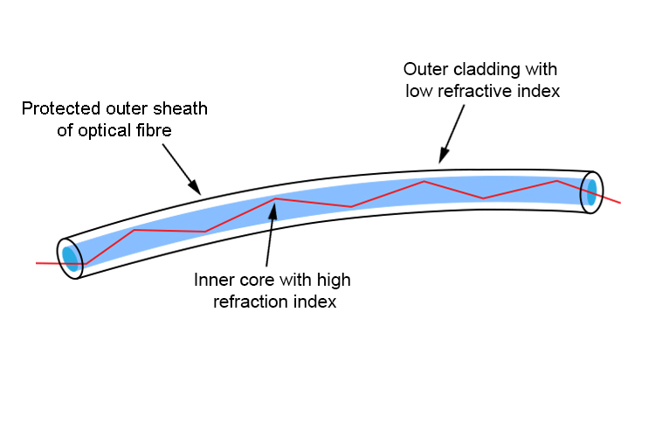  Rajah 11.3  Diagram 11.3  Anda dikehendaki untuk mencadangkan ciri-ciri yang sesuai supaya fiber optik itu dapat digunakan dalam komunikasi. dan perubatan.  Nyata dan terangkan cadangan anda berdasarkan aspek-aspek berikut:  You are assigned to give suggestions on the characteristic of the optical fiber  so that it can be used in communications and medicine.  State and explain your suggestion based on the following aspects.  (i) Sifat fiber optic.  Features of optical fiber.  (ii) Perbandingan indeks biasan teras dalam dan lapisan luar.  Comparison between refractive index of inner core and the outer cladding.  (iii) Kelenturan.  Flexibility.  (iv) Ketulenan teras dalam.  Purity of inner core.  (v) Ciri tambahan.  Additional features.  [10 markah]  [10 marks]
 | (d) | Rajah 11.4 menunjukkan satu sinar cahaya merambat ke dalam prisma kaca  yang mepunyai sudut genting 42^{0.}  Diagram 11.4 shows a light ray propagate towards a glass prism which has refractive of 1.5.  Prisma kaca  Glass prisim  B  x˚  Rajah 11.4  Diagram 11.4  Terangkan apakah yang akan berlaku kepada sinar cahaya itu pada titik B jika  Explain what will happen to the light ray at point B if  (i) x = 30⁰  (ii) x = 50⁰  [4 markah]  [4 marks]

END OF QUESTION PAPER
KERTAS PEPERIKSAAN TAMAT

